# Social tiles and messaging templates

This resource is designed to be both broad and varied to allow you to choose the messages that best suit your audience and community. You may choose to share them “as is”, or you may want to adapt the captions or statements to suit the audience you are speaking to. We have suggested a website link for the posts, but you may want to update to direct to your own work or website.

For example, you may want to speak directly to the rights of women with disabilities, women from a faith community, trans women or First Nations women. Many women experience intersecting forms of discrimination, and very few people hold just one identity or experience.

For all social media activities, join the conversation by using the hashtags #16Days and #16DaysOfActivism. Make sure you tag us in your social media posts!

* Twitter/X: @Respect_Vic
* Instagram: @respectvictoria
* Facebook: @RespectVictoria
* LinkedIn: Respect Victoria

[Download all social media files, using Digital Pigeon](https://respect-victoria.digitalpigeon.com/shr/lTb9kG5CEe6-iwZIlpBgGQ/oZrPG3AokrGYS14uR4naQA).

## Social tile 1

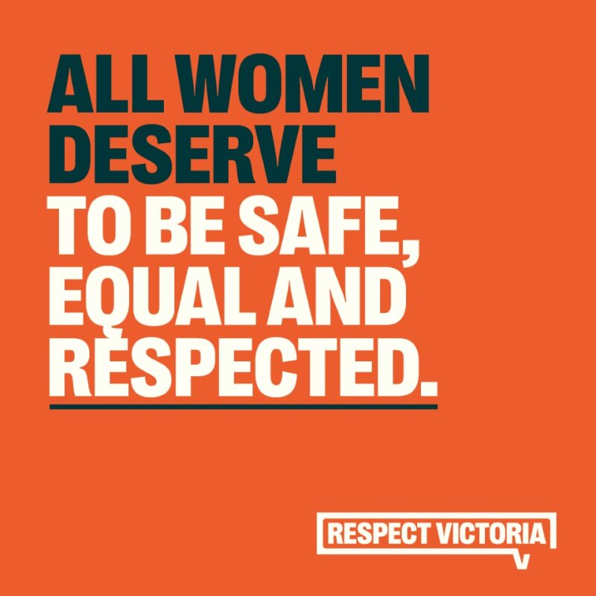

### Social tile statement

All women deserve to be safe, equal and respected.

### Alt text

All women deserve to be safe, equal and respected.

### Supporting copy

Violence against women can be prevented. Every 10 days one woman is killed by a man they know. It doesn’t have to be this way.

This 16 Days of Activism and beyond, let’s change the story and create a future where we are all safe, equal and respected.

To learn more about 16 Days of Activism, visit: <https://tinyurl.com/3vzne4zd>

#16Days #16DaysOfActivism

### Additional notes on messaging

The statistic used in this copy is based on homicide data from recent years. You may choose to use this statistic or use one that speaks specifically to the community you are speaking to (for example, you may want to use a statistic about women with disabilities or First Nations women).

## Social tile 2

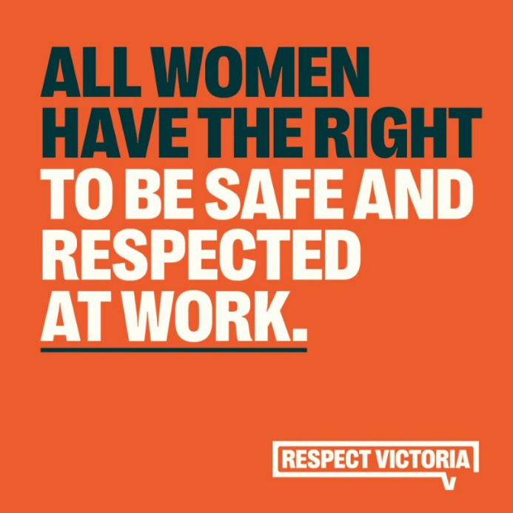

### Social tile statement

All women have the right to be safe and respected at work.

### Alt text

All women have the right to be safe and respected at work.

### Supporting copy

We can all help create workplaces where everyone is respected.

By challenging harmful attitudes and behaviours, we can prevent violence against women before it starts.

To learn more about 16 Days of Activism visit: [https://tinyurl.com/y2fwst6j](https://tinyurl.com/y2fwst6j%20%20)

#16Days #16DaysOfActivism

### Additional notes on messaging

You may want to expand on this caption by talking about the way tasks are shared in workplaces, who talks the most in meetings, who cleans up the lunchroom.

You may want to add a specific barrier to the middle of the message; it may be a statistic on sexual harassment, or a message about the gender pay gap.

You could talk about preventing sexual harassment in workplaces, workplace gender equality policies, or flexible work.

## Social tile 3

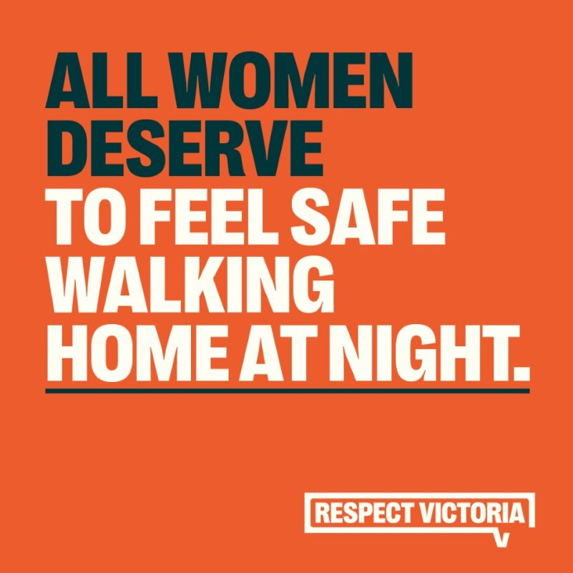

### Social tile statement

All women deserve to feel safe walking home at night.

### Alt text

All women deserve to feel safe walking home at night.

### Supporting copy

Women deserve to be safe in their homes and on the streets.

All women deserve a world where they don’t need to hold their keys between their fingers or look over their shoulder.

To make our communities safer, we must address the harmful attitudes and entitlement that drive violence.

To learn more about 16 Days of Activism visit: <https://tinyurl.com/yc88tev6>

#16Days #16DaysOfActivism

### Additional notes on messaging

This statement could be used as is, or it could be expanded on to talk about the added layers of discrimination some women can experience in public spaces (like racism or ableism), and how we can work together to prevent them.

## Social tile 4

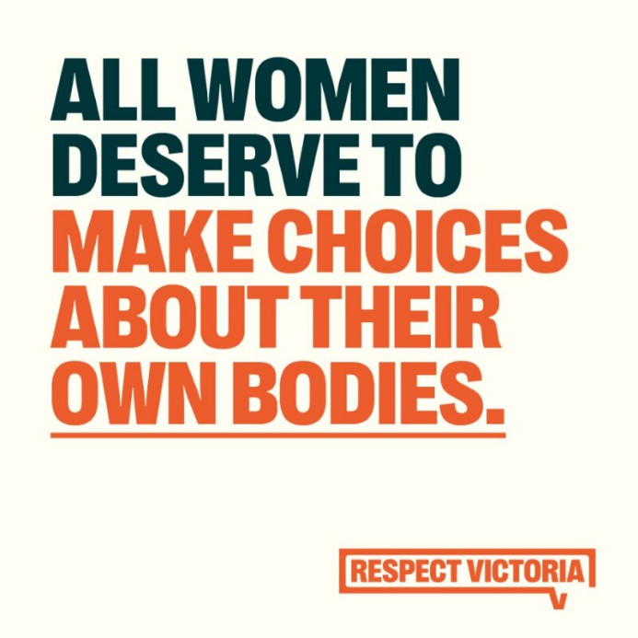

### Social tile statement

All women deserve to make choices about their own bodies.

### Alt text

All women deserve to make choices about their own bodies.

### Supporting copy

We must uphold the rights of women to make decisions about their own bodies, free from discrimination.

Everyone deserves the right to make choices about their own bodies.

To learn more about 16 Days of Activism visit: <https://tinyurl.com/2p9x9dcr>

#16Days #16DaysOfActivism

### Additional notes on messaging

This statement could be used to talk about reproductive rights, consent, disability rights, gender affirming care, beauty standards, or any other situation where women’s choices are questioned or removed.

## Social tile 5

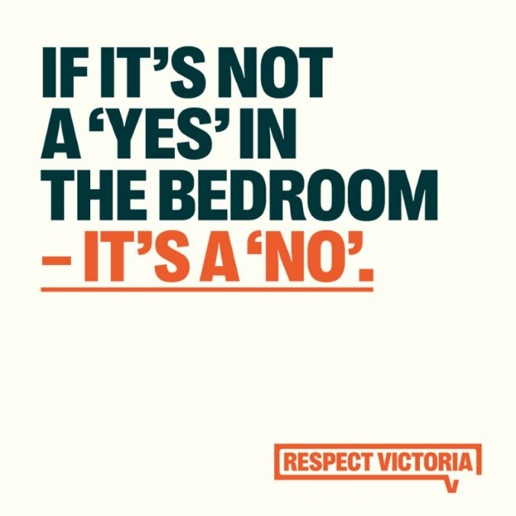

### Social tile statement

If it’s not a ‘yes’ in the bedroom – it’s a ‘no’.

### Alt text

If it’s not a ‘yes’ in the bedroom – it’s a ‘no’.

### Supporting copy

Consent is about respecting your partner.

It’s everyone’s responsibility to actively seek consent from a sexual partner - whether it’s someone you’ve been with for years, a first date, or someone you meet at a party.

Consent can be given and withdrawn at any time, so it’s important to keep checking in.

To learn more about 16 Days of Activism visit: <https://tinyurl.com/4mm7dtvw>

#16Days #16DaysOfActivism

## Social tile 6

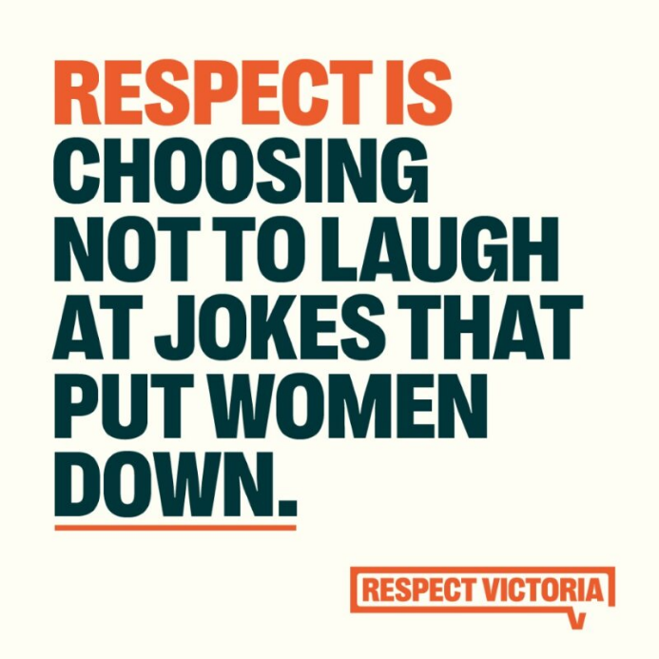

### Social tile statement

Respect is choosing not to laugh at jokes that put women down.

### Alt text

Respect is choosing not to laugh at jokes that put women down.

### Supporting copy

Choosing not to laugh at jokes that put women down helps create a culture where women are respected.

Each of us has a role to play – by challenging harmful behaviours early, we can prevent violence before it starts.

To learn more about 16 Days of Activism visit: <https://tinyurl.com/5n7sep9d>

#16Days #16DaysOfActivism

## Social tile 7

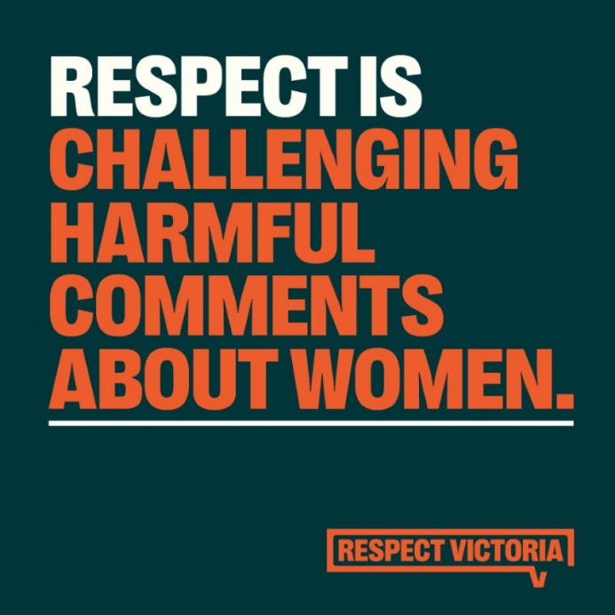

### Social tile statement

Respect is challenging harmful comments about women.

### Alt text

Respect is challenging harmful comments about women.

### Supporting copy

Each of us can play a role in creating a society that is safe and equal for women.

By challenging harmful comments in your workplace, sporting club, friendship group and community, you can help prevent violence against women before it starts.

To learn more about 16 Days of Activism visit: <https://tinyurl.com/2sfmpk2k>

#16Days #16DaysOfActivism

### Additional notes on messaging

You may want to add other settings or locations into the caption, or get specific about one setting (for example, sporting field or community group).

## Social tile 8

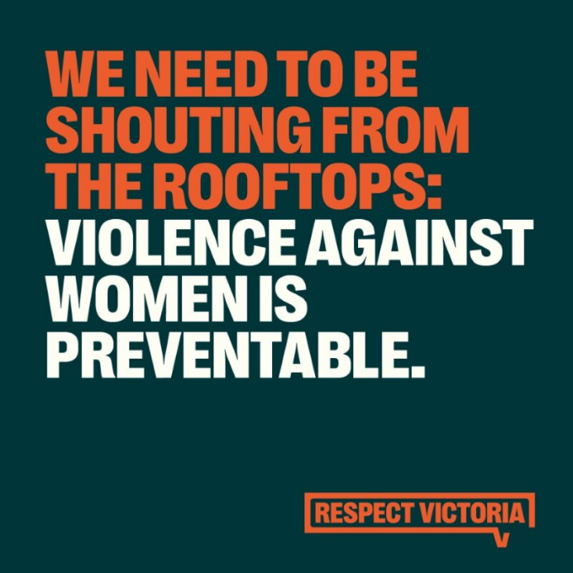

### Social tile statement

We need to be shouting from the rooftops: violence against women is preventable.

### Alt text

We need to be shouting from the rooftops: violence against women is preventable.

### Supporting copy

All women should be safe, equal and respected.

But every 10 days one woman is killed by a man they know.

We need to start talking about what drives this violence, and the changes we can all make to prevent it from happening.

To learn more about 16 Days of Activism visit: <https://tinyurl.com/bdhxd4pj>

#16Days #16DaysOfActivism

## Social tile 9

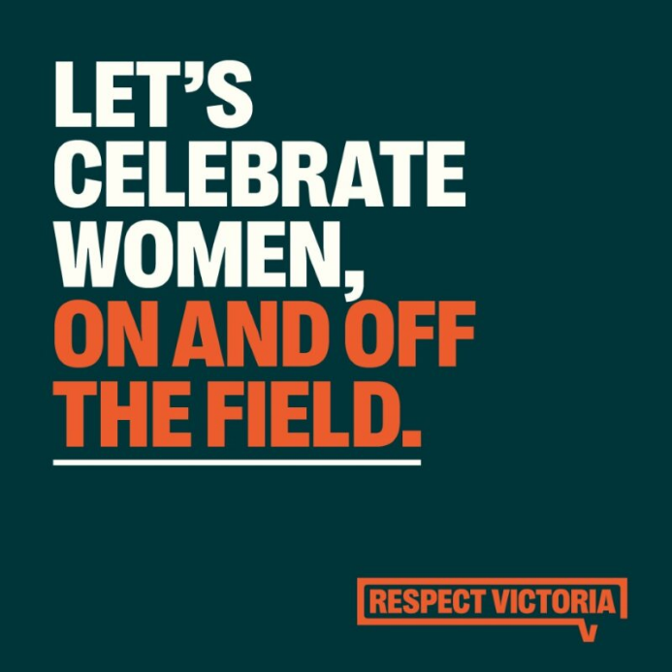

### Social tile statement

Let’s celebrate women, on and off the field.

### Alt text

Let’s celebrate women, on and off the field.

### Supporting copy

Sport brings communities together, gives us a sense of belonging, and has the power to create change.

By celebrating women in sport, we help create a culture where everyone can be on the field, and women and girls are valued.

To learn more about 16 Days of Activism visit: <https://tinyurl.com/42c82tm9>

#16Days #16DaysOfActivism

### Additional notes on messaging

This is a great opportunity to talk about a current or recent sporting win for women (e.g., The Matilda’s or the current AFLW season), or to highlight changes your organisation or council is making to ensure your community sport centres and accessible and equal for women.

You may also want to add a ‘barrier’ to this caption – for example: pay discrimination, sexism on and off the field, access to changerooms and facilities.

## Social tile 10

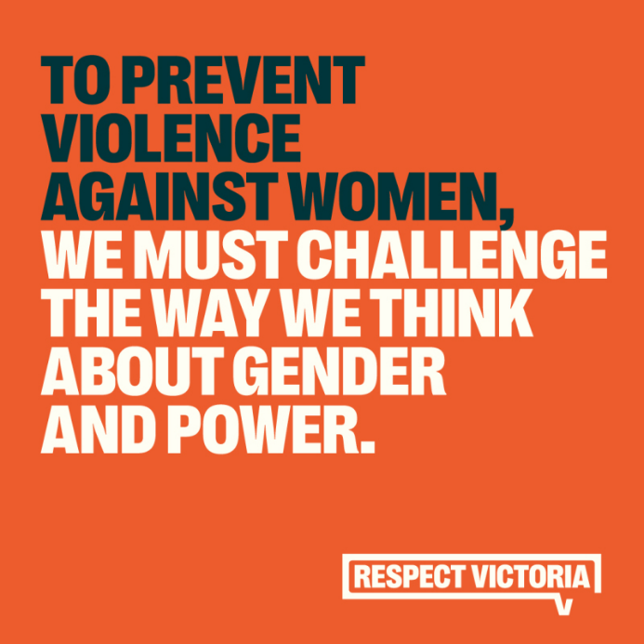

### Social tile statement

To prevent violence against women, we must challenge the way we think about gender and power.

### Alt text

To prevent violence against women, we must challenge the way we think about gender and power.

### Supporting copy

We have made big strides over recent decades when it comes to equality, but we know that harmful ideas about gender and who holds power show up in our homes, workplaces and communities.

To prevent violence against women, we must challenge harmful ideas about gender, power and what relationships should look like.

To learn more about 16 Days of Activism visit: <https://tinyurl.com/mu37udd9>

#16Days #16DaysOfActivism

## Social tile 11

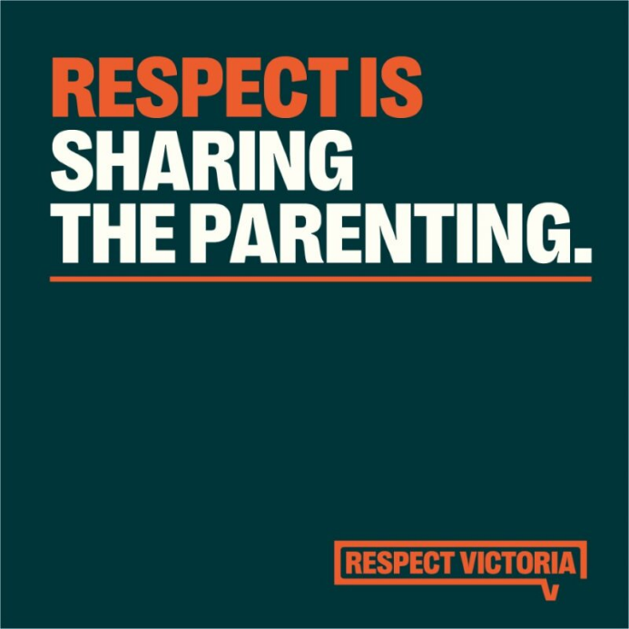

### Social tile statement

Respect is sharing the parenting.

### Alt text

Respect is sharing the parenting.

### Supporting copy

Sharing the parenting in a way that works for everyone helps model equality and respect.

Right now, women take on the majority of unpaid labour in Australian households – up to an extra 21 hours per week.

Taking into account everyone’s commitments and making sure one person isn’t taking on most of the work is important in creating a healthy relationship and family.

To learn more about 16 Days of Activism visit: <https://tinyurl.com/yc6zm9ab>

#16Days #16DaysOfActivism

## Social tile 12

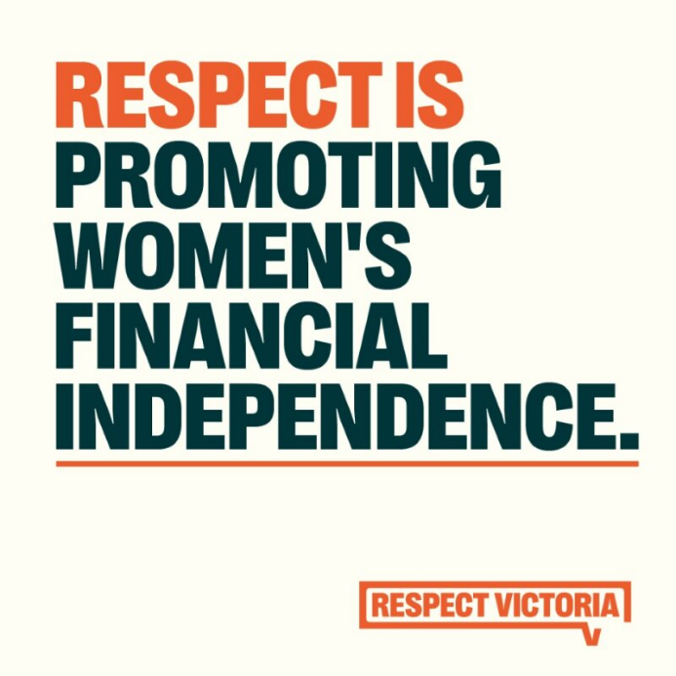

### Social tile statement

Respect is promoting women's financial independence.

### Alt text

Respect is promoting women's financial independence.

### Supporting copy

Women deserve financial security and independence. This can look like closing the gender pay gap in workplaces, equal parental leave policies, and valuing care work.

Promoting women’s financial independence is critical to prevent violence against women.

To learn more about 16 Days of Activism visit: <https://tinyurl.com/53dt4ves>

#16Days #16DaysOfActivism

## Social tile 13

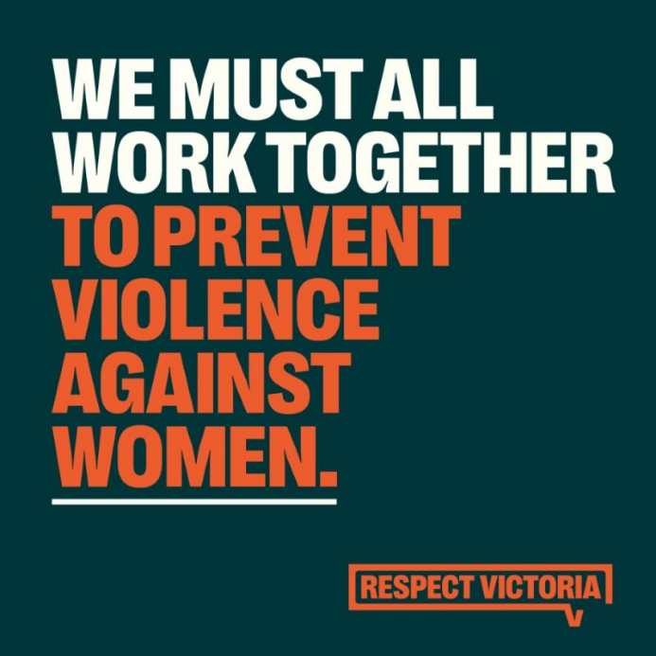

### Social tile statement

We must all work together to prevent violence against women.

### Alt text

We must all work together to prevent violence against women.

### Supporting copy

To create the transformational change needed for everyone to be safe and equal, we must act together in solidarity to dismantle the attitudes that drive violence against all women.

We must act together for all women and move towards a better future.

To learn more about 16 Days of Activism visit: <https://tinyurl.com/mryamwrw>

#16Days #16DaysOfActivism

## Social tile 14

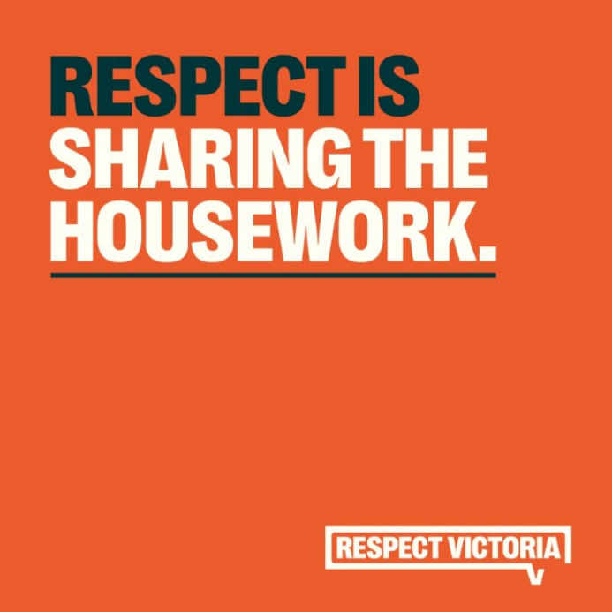

### Social tile statement

Respect is sharing the housework.

### Alt text

Respect is sharing the housework.

### Supporting copy

Sharing the housework helps us build relationships based on mutual respect.

Right now, women do 21 more hours of unpaid labour per week than men.

Gender equality begins at home. By fostering equality in our homes, we create a safer community for women and girls.

To learn more about 16 Days of Activism visit: <https://tinyurl.com/4c868wff>

#16Days #16DaysOfActivism

### Additional notes on messaging

If you are interested in sharing more on equal labour in households, take a look at Meaghan and Ed’s story from our recent campaign: [Respect Starts With A Conversation](https://www.respectvictoria.vic.gov.au/campaigns/respect-starts-with-a-conversation).

## Social tile 15

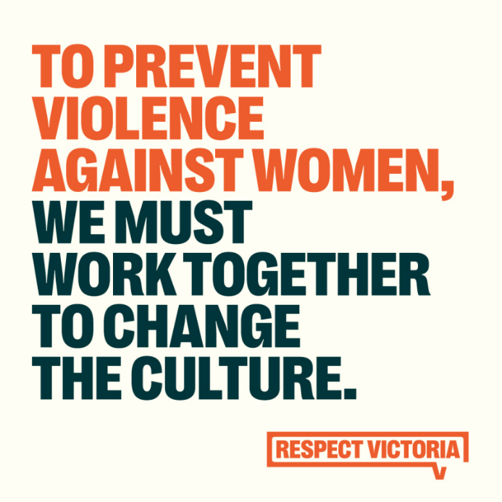

### Social tile statement

To prevent violence against women, we must work together to change the culture.

### Alt text

To prevent violence against women, we must work together to change the culture.

### Supporting copy

Right now, we all face unfair assumptions and treatment based on gender.

Violence against women happens because we allow it to.

It doesn’t have to be this way. Preventing violence against women starts with respectful conversations.

To learn more about 16 Days of Activism visit: <https://tinyurl.com/2mp9rxd7>

#16Days #16DaysOfActivism

### Additional notes on messaging

You may like to expand on this to include some of the ideas we are seeking to challenge, for example:

* Women still do most of the housework and parenting, experience pay discrimination, and deal with victim-blaming.
* Men are often still told to be tough and in control, the breadwinners, the secondary parent.
* It’s limiting ideas like this that drive this harm and lead to violence against women.

## Social tile 16

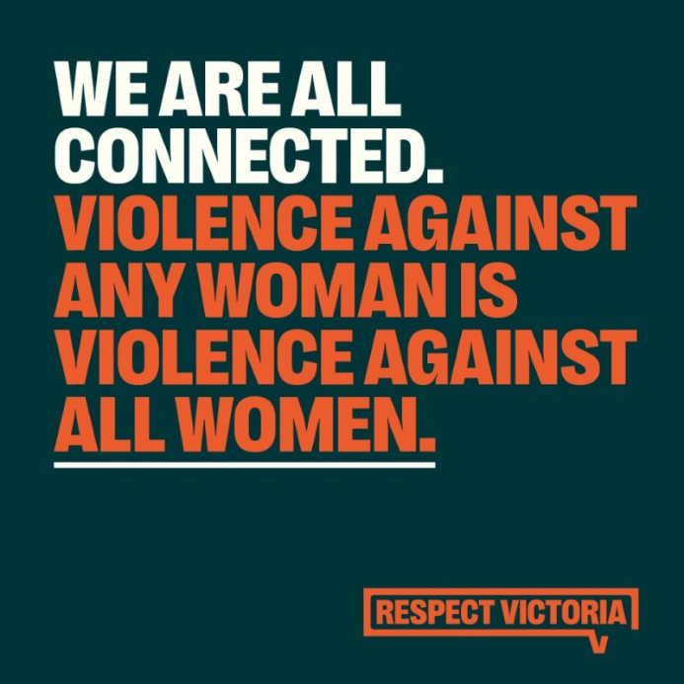

### Social tile statement

We are all connected. Violence against any woman is violence against all women.

### Alt text

We are all connected. Violence against any woman is violence against all women.

### Supporting copy

We can work together to create a future where all women are safe, equal and respected.

As a community, we must challenge harmful attitudes in our workplaces, homes, sports clubs, community groups and relationships.

To learn more about 16 Days of Activism visit: <https://tinyurl.com/29ykhxhk>

#16Days #16DaysOfActivism

### Notes on messaging

You may like to use this statement to talk about the shared experiences that many women hold. For example, allyship and solidarity between cisgender and transgender women.