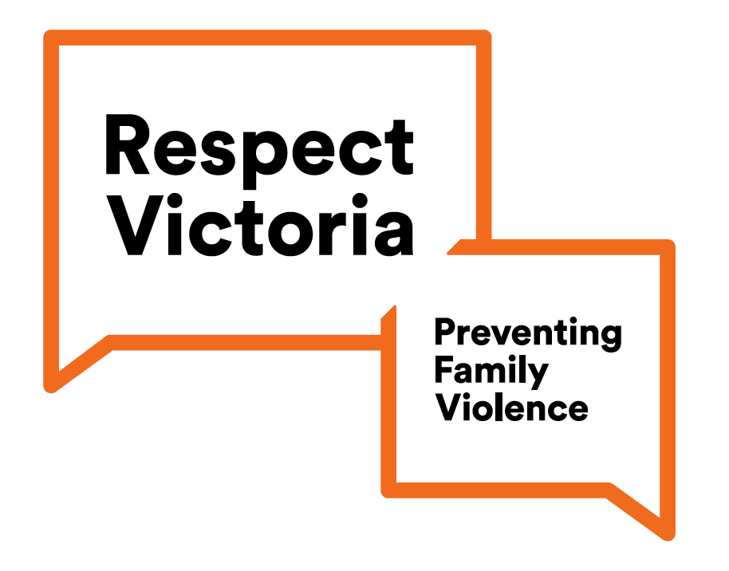

Respect Victoria
Strategic Plan Overview 2019 - 2022

Building strong foundations for sustained primary prevention of all forms of family violence and violence against women

Who we are
Respect Victoria is an independent Statutory Authority dedicated to the primary prevention of all forms of family violence and violence against women. Our focus is on stopping violence before it starts by changing the culture that allows it to happen.
We do this by following a primary prevention approach. Primary prevention works by identifying the underlying causes – or drivers – of violence. These include the social norms, practices and structures that influence individual attitudes and behaviors. Primary prevention focuses on challenging these driver across the whole community.

Vision
All people are safe, equal and respected, and free from all forms of family violence and violence against women.

Purpose
To prevent all forms of family violence and violence against women before they happen, by driving evidence-informed primary prevention.

Principles
Our work is guided by the following principles:
Human rights | Human rights are essential in a democratic and inclusive society that respects the rule of law, human dignity, equality and freedom.
Gender equality | Gender equality is the precondition for a more equal society and includes the social right, responsibilities and opportunities of women, men, trans and gender diverse people.
Self-determination | Self-determination is the foundation for better outcomes for Aboriginal people. It is an approach that recognizes and respects the inherent strength and diversity of Aboriginal people, families and communities.
Intersectionality | Intersectionality recognizes people’s lived experiences and the interconnected nature of their identities across gender and gender identities, sexual orientation, race ethnicity, Aboriginality, language, religion, class, socio-economic status, ability and age.

Pillars
To achieve our vision, we will:
- Research, monitor and evaluate | Inform policy and practice through research, monitoring and evaluation into the drivers of violence and how violence can be prevented.
- Communicate and engage | Build community awareness of the drivers of all forms of family violence and violence against women, contribute to cultural change and challenge these drivers.
- Drive uptake | Drive uptake of best practice primary prevention by setting the standard and supporting policy makers and practitioners in government, industry, organisations and communities.
- Coordinate and collaborate | Coordinate and collaborate to strengthen primary prevention across government, industry, organisations and communities.
- Advise and influence | Advise and positively influence government, industry and organisations on effective primary prevention policy, practice and investment.

Values
Accountability | We are accountable to victim-survivors, the community and government
Collaboration | We know that together we can do more
Courage | We forge a new path to guide others
Excellence | We are thorough in our work and strive for excellence in everything we do.
Leadership | We set the standard and provide stewardship
Persistence | We continue our work until all forms of family violence and violence against women are eradicated

Foundations
As a new organisation, priority will be given to developing robust governance, organisational and core business functions that allow us to deliver on our purpose.

Family violence services and support
In an emergency, call Triple Zero (000).
If you, or someone you know, is affected by sexual assault, domestic or family violence, call 1800RESPECT (1800 737 732) or Safe Steps (1800 015 188) to talk to a free confidential counsellor, available 24 hours seven days a week. You can also visit 1800RESPECT.org.au or www.safesteps.org.au.
www.respectvictoria.vic.gov.au {Twitter} @Respect_Vic {Facebook} @RespectVictoria

March 2019

