Respect Victoria Strategic Plan 2023-2028   
Overview

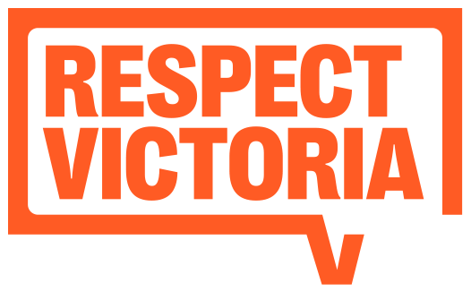Image description: Respect Victoria Logo

# Our strategic plan

## Our vision

A Victorian community where all people are safe, equal and respected, and live free from family violence and violence against women.

## Our purpose

To lead and support evidence-informed primary prevention and be a catalyst for transformational social change.

## Our strategic pillars

1. Prevention system

Drive an effective and coordinated primary prevention system

1. Knowledge and evidence

Build and promote primary prevention knowledge and evidence

1. Policy and Public Agenda

Keep prevention on the policy and public agenda

1. Guidance and support

Guide effective and impactful primary prevention efforts

1. Social change

Influence community and social change

## Our values

### Courage

We are bold, brave and fearless

### Integrity

We are rigorous, evidence-informed and accountable

### Leadership

We are aspirational, strategic, collaborative and dedicated

## Our strategic pillarS and priorities

1. – Drive an effective and coordinated primary prevention system
   1. Establish new prevention system infrastructure and mechanisms to enable more coordinated and coherent primary prevention activity across Victoria.
   2. Inform, support and collaborate with stakeholders to strengthen state and national prevention infrastructure and system capability.
   3. Build a statewide monitoring and evaluation system that enables ongoing learning about primary prevention progress and impact across Victoria.
2. – Build and promote primary prevention knowledge and evidence
   1. Bring together and translate findings from available data, research and evaluation to build new knowledge about family violence, violence against women and effective prevention approaches.
   2. Build evidence on the use and effectiveness of saturation models, and opportunities for scale-up and systematisation of primary prevention initiatives.
   3. Support research and evaluation that builds evidence to inform policy, practice, programming and social norms change.
   4. Work with partners and stakeholders to enable the application of research and evaluation outputs to inform prevention efforts.
3. – Keep prevention on the policy and public agenda
   1. Provide expert advice to the Victorian and Federal Government to inform and influence primary prevention policy, legislation, regulation and investment.
   2. Leverage our unique role and relationships with sector and industry leaders to increase their commitment to primary prevention and drive meaningful action across institutions.
   3. Lead a community-wide conversation on the prevention of violence against women to influence public sentiment and commitment to change.
4. – Guide effective and impactful primary prevention efforts
   1. Develop standards and guidelines to support the implementation of quality, evidence-informed primary prevention within and across settings and sectors.
   2. Broaden the reach of mutually reinforcing prevention initiatives by driving uptake across a wider range of settings and sectors.
   3. Develop resources and tools to enable consistent and effective evaluation of primary prevention initiatives.
   4. Contribute to the growth and strengthening of an expert, multidisciplinary primary prevention workforce.
5. – Influence community and social change
   1. Develop, deliver and evaluate social marketing campaigns with a focus on the gendered drivers of violence against women.
   2. Better connect our campaigns and messaging to primary prevention activities being implemented across Victoria.
   3. Engage with a range of mainstream and industry-specific media to raise awareness of and encourage community conversations about prevention of family violence and violence against women.
   4. Mobilise individuals and communities to play an active role in primary prevention by connecting them to prevention messages, information and tools.

© Respect Victoria 2023

Respect Victoria acknowledges the support of the Victorian Government

Respect Victoria Strategic Plan 2023-2028 Overview

ISBN 978-1-76130-090-5 (Print) ISBN 978-1-76130-091-2 (pdf/online/MS Word)

Image description: Victorian Government Logo

