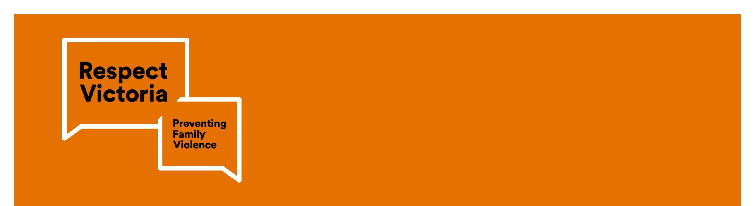

|  |
| --- |
| Respect Women: ‘Call It Out’ Active Bystander Campaign |
|  |

If you are concerned for your safety or that of someone else, please contact the police in your state or territory or call Triple Zero (000) for emergency services.

## It’s easy to tune out during rush hour. But it’s good to stay present and be aware of other commuters. With around two million passengers a day using Victoria’s trains, trams and buses; we all have a role to play in calling out sexual harassment.

There’s a big difference between eye contact and leering  
‘Sexual harassment’ is any form of unwelcome sexual behaviour that can be offensive, humiliating or intimidating. It can be obvious or indirect, physical or verbal, repeated or one-off.

On public transport, sexual harassment may include[1]:

* staring or leering
* deliberately brushing up against you or unwelcome touching
* suggestive comments or jokes
* insults or taunts of a sexual nature
* intrusive questions or statements about your private life
* behaviour that may also be considered to be an offence under criminal law, such as physical assault, indecent exposure, sexual assault, stalking or obscene communications.

This campaign is designed to bring all Victorians into the conversation around sexual harassment on public transport by providing the tools to call out inappropriate behaviours. Safety in public spaces is everyone’s business and every commuter has the right to make it home safely.

### Sexual harassment happens all too often

A lot of people are surprised to learn how common sexual harassment is. Research shows many women having experienced sexual harassment in public places. Despite this, many of these instances remain unreported, with victims feeling ashamed or helpless. Sometimes, victims are not being aware that sexual harassment has even occurred.

Sexual violence is prevalent in Australian society with half of all Australian women reporting that they have been sexually harassed[2].

The latest data from the Crime Statistics Agency shows that between 2015-16 and 2017-18, the number of sexual offences at train stations jumped by 70 per cent, with the number of reported sexual offences - which include groping, molesting and rape - rising from 82 to 141 across all train stations.

In 2017, survey results from the Australian Human Rights Commission (AHRC) revealed concerning statistics about the number of university students sexually harassed and sexually assaulted on Australian public transport. Of university students sexually harassed in 2015 and 2016, an average of 22 per cent were harassed on public transport while travelling to or from university[3]. Some university percentages were significantly higher — ranging up to 40 per cent. For incidents of sexual assault, an average of 15 per cent occurred on or near public transport.

### How to call out sexual harassment

As our campaign shows, even the smallest of acts can potentially stop sexual harassment from occurring. Learning to recognise the signs when someone is in danger and stepping in to help prevent the situation from escalating is important. This is called being an active bystander. Active bystanders learn how to recognise and safely intervene in potentially dangerous situations.

Some simple steps to becoming an active bystander include:

* noticing the situation (being aware of your surroundings – that means looking up from your phone and making a conscious decision to be present)
* interpreting the problem (do I recognise someone needs help?)
* feeling compelled to act (seeing yourself as being part of the solution to help – considering the difference that your actions could make by being an active bystander)
* knowing what to do (consider what you would do and when you would do it)
* Intervening safely (taking action but being sure to keep yourself and those around you safe).

### What to do if you are experiencing sexual harassment

If you are experiencing sexual harassment on public transport and you are in immediate danger call Triple Zero (000) or (where possible) press the button in the carriage to speak to the train or tram driver at the time the harassment is occurring.

If you’re in a position where you’re feeling vulnerable and cannot make a phone call to Triple Zero (000), there are other ways to call out these behaviours. This may include sending a text message to a close friend or family member where you can advise them of your location and where the harassment is occurring so that they can ring Triple Zero (000) and police can attend at the next stop or station.

If you do feel vulnerable in that space, you should (where safe) move away from the area where the perpetrator is and if you are in immediate danger call Triple Zero (000). If you do feel uncomfortable, try and get the attention of other passengers to assist.

**Your safety is priority, and you should only act in a way that does not endanger yourself or those around you further.**

### Reporting sexual harassment

Only by reporting sexual harassment on public transport will we stop these inappropriate acts being committed in public places. If you have experienced sexual harassment, you can report information to Crime Stoppers on 1300 333 000 from 8.00am-11.00pm, 7 days a week.

No incident or detail is too small or trivial and it is important to remember that what you have experienced is not your fault. You will always be taken seriously and treated with respect. If you experience unwanted sexual behaviour, we encourage you to report it.

### For further assistance

If you have experienced sexual assault or sexual harassment and feel you would like to speak to someone for support or information, 1800RESPECT (Phone: 1800 737 732) provides counselling 24-hours a day, 7 days a week.

### Get involved!

This year, Respect Victoria aims to get as many people from right across the state of Victoria to understand the most effective and safest ways to call out all forms of sexual harassment witnessed on public transport. By sharing the links below and continuing the conversation around how to call it out; together we can all play our role in ensuring that everyone’s commute is a safe and secure journey.

By challenging the harmful norms, practices and structures that lead to violence – gender inequality, marginalisation and discrimination – together we can create a Victoria free from violence.

1. Australian Human Rights Commission, <https://www.humanrights.gov.au/our-work/sex-discrimination/guides/sexual-harassment>
2. Australian Bureau of Statistics, 4906.0 - Personal Safety, Australia, 2016, <https://bit.ly/2WCFI1d>
3. Australian Human Rights Commission, Change the course: national report on sexual assault and sexual harassment at Australian universities (2017)